Rhodes

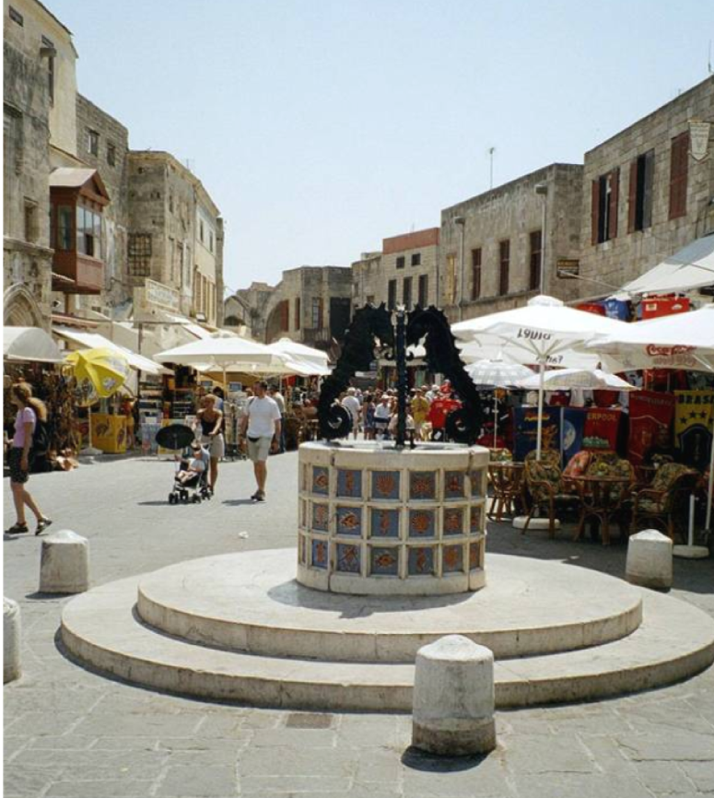
World War II
There were close to 2,000 Jews living on the island of Rhodes and the synagogue, built in 1575, was the oldest functioning synagogue in Greece.
There had been a Jewish community in Greece for approximately 2,300 years.
Initially during the war Rhodes was ceded to Italy, and until September 1943 the Jews of Rhodes lived in relative safety.

From September 1943 the island was under German occupation. On 20 July 1944, the Jews of Rhodes and of the neighbouring island of Kos were the last Greek Jews to be deported.
Under the hot summer sun they were crowded into boats and taken to the Greek mainland, 23 died on the voyage. On arrival they were incarcerated in an SS camp before being deported to Auschwitz-Birkenau, where most of them were murdered.
Only 151 Jewish people from Rhodes survived the Holocaust, and today there are only 35 Jewish people living on the island. The synagogue still stands in the ‘Juderia’ a testimony to the thriving community that once lived here.
What we see in this photograph has been described as being the ‘creative act of genocide’ – the void that remains once the people and the future generations of the community have been destroyed by genocide.

