Chapter 3.1 How did life change for German Jews?

Resource sheet 3.1.1 Jewish emigration from Nazi Germany
When the Nazis came to power Jewish people were fearful: they knew that the Nazis were antisemitic. Then, very quickly, the Nazis began to make life very unpleasant for Jewish people. Given this, why didn’t Jewish people just leave?
The map below shows us that between 1933 and 1939 many Jewish people did leave Germany. But, many more did not.

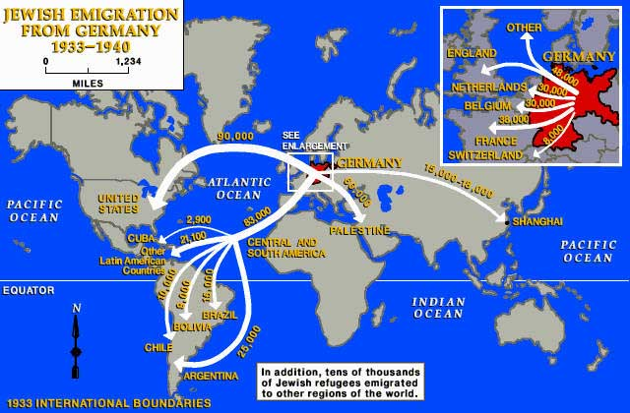
https://www.jewishvirtuallibrary.org/jewish-emigration-from-germany-1933-1939
KEY WORD
Emigration – leaving the country you live in to move to a different country. This movement might be voluntary, or it might be forced upon someone by war, conflict, or natural disaster.
TASK:
- Note down the countries where Germany’s Jews emigrated to.
- Using your knowledge from chapter 3.1 explain why Germany’s Jews may have chosen these particular countries.

CASE STUDY: Anne Frank and her family
You may have already heard of Anne Frank. Anne famously kept a diary whilst she and her family were in hiding from the Nazis and their collaborators in the Netherlands during the Second World War. Her diary was published years later and has now been read by millions of people worldwide.
Like thousands of other German Jews, Anne Frank and her family left Germany in the 1930s. Use this website to find out more about why Anne and her family left Germany, their life in the Netherlands both before and during the Nazi occupation and what happened to them:
https://www.annefrank.org/en/anne-frank/

CASE STUDY: Jewish emigration to Shanghai
You may have noticed from the map above that significant numbers of Germany’s Jews immigrated to Shanghai. Use this website to find out more about why so many went to Shanghai and what their lives were like there:
https://encyclopedia.ushmm.org/content/en/article/german-and-austrian-jewish-refugees-in-shanghai

